Fetal Health Detection using CatBoost with Feature Selection techniques
Parusha Sindhu¹, Vadde Mokshitha³,
Computer Science & Engineering Department, Computer Science & Engineering Department,
S R University, Warangal, India S R University, Warangal, India
Bethi Naveen Kumar^{2 *},
Computer Science & Engineering Department,
S R University, Warangal, India

Abstract- Pregnancy is a sensitive period where continuous monitoring is necessary to ensure fetal well-being and safety. The condition of the fetus is strongly influenced by the health of the Cardiotocography (CTG) is widely used as a monitoring tool to observe fetal conditions and support early prediction. This study presents a predictive framework based on the CatBoost algorithm for classifying fetal health conditions. To enhance its predictive performance, three Feature Selection (FS) techniques such as Analysis of Variance (ANOVA), Mutual Information (MI), and Correlation
Coefficient (CC) are employed to extract the most significant features from the CTG data. Comparative analysis demonstrated the impact of FS on the model performance in terms of accuracy, precision, recall, and F1score. The findings indicate that the proposed approach can offer a reliable and efficient method for fetal health monitoring and risk assessment.
Keywords- Cardiotocography,
Classification, feature selection, CatBoost

I. INTRODUCTION
Perinatal mortality refers to deaths occurring either before birth or within the first week of life. According to global health reports, millions of perinatal deaths

occur annually, with higher rates in developing regions. These rates are often measured per 1,000 births and are closely tied to a country's level of development. In high-income nations, the rate is typically below 10 per 1,000 births, whereas in less developed regions, it is significantly higher, exceeding 30 in the least developed countries [1]. Fetal heart rate is a vital marker of fetal well-being, and obstetricians commonly use cardiotocography (CTG) to monitor it. CTG data provides valuable information that helps obstetricians identify potential fetal abnormalities and determine whether medical intervention is required before the baby suffers long-term harm. Although CTG data is often interpreted visually by obstetricians, this approach may not always ensure high accuracy. As a result of being susceptible to human interpretation errors, the number of wrong diagnosis and caesarean sections increases. This has encouraged researchers to develop automated systems that use their engineering and medical expertise to evaluate and categorise CTG recordings.
Recent advancements in machine learning have enabled automated analysis of CTG data for fetal health prediction. Various models such as Random Forest, Support Vector Machines, and Neural Networks have been explored in previous studies. Among these, ensemble methods have shown strong performance due to their ability to combine multiple weak learners and improve prediction accuracy. Such systems are capable of detecting early signs of fetal distress, allowing timely medical intervention to prevent complications. Sahin et al. (2015) has examined eight classifiers including Random Forest (RF), Artificial Neural Network (ANN), K-Nearest Neighbour (KNN), Support Vector Machine (SVM), Linear Regression (LR), Radial Basis Functional network (RBFN), and two Decision Trees (DT): CART and C4.5 with the UCI CTG dataset in [2] for fetal state identification. With an accuracy of 99%, their analysis shows that RF is better to other models. They have not analysed the impact of feature selection over the performance of the classifiers.Piri et al. has introduced an association-based classification named as (CBA) utilizing RF as a feature selection (FS) strategy for analyzing fetal health using CTG data in [3]. With a reduced set of 10 features the model has achieved an accuracy of 84%. However, when it is compared seven other classifiers (RF, LR, SVM, KNN, DT, XGBoost and GNB), RF and XGBoost both produced the maximum accuracy of 93% with FS. In [4], a deep stacked sparse auto-encoder (DSSAEs) suggested for state classification of the fetus is found to be superior to MLA-ANFIS, NN and deep ANFIS models
achieving an accuracy of 99.5% without employing any FS technique. In [5], performance of two rule based classifiers (Jrip, Ridor), DT, Naïve Bayes (NB), and two lazy learners (IBK, Kstar) are analysed with three FS techniques such as Chi-square, Information gain and ReliefF and employing SMOTE based data balancing approach for fetal state classification. With unbalanced and balanced dataset, selecting top 6 features by Chi-suare, Jrip classifer achieved the highest accuracy of 98% outperforming other classifiers. Piri et al. (2020) has investigated the performance of seven classifiers (SVM, LR, RF, DT, KNN, GNB, XGBoost) with a Multi-Objective Genetic Algorithm (MOGA) based FS approach for fetal health classification from CTG recordings [6]. Applying FS, the accuracy of SVM, RF and GNB are improved, whereas it remains same with the accuracy obtained without FS for XGBoost, and LR, and KNN exhibit slightly less accuracy with FS compared to without FS. Overall, with a reduced set of seven features the XGBoost classifier is observed to achieve the highest accuracy of 94% outperforming other classifiers. A bagging ensemble with RF model is suggested in [7] for classifying fetal health status using CTG data. With an accuracy of 99%, the ensemble model has demonstrated superior performance when compared to SVM, KNN, ANN, and DT. In
[8], a deep forest model is suggested, which is designed by integrating Random Forest (RF), Weighted RF, Completely RF and Gradient Boosting Decision Tree for identifying the fetal health status. When compared with DT, NB, SVM, KNN and RF, the deep forest model has shown better performance attaining an accuracy of 98%. A novel ensemble cost sensitive SVM is suggested in [9] to classify CTG signals as normal or abnormal. The study demonstrates that incorporating timefrequency features along with traditional linear features, and using them as input to ECSVM classifier, significantly improves the classification of abnormal CTG signals. The area under the ROC curve increases significantly from 0.64 obtained by SVM to 0.77 using ECSVM, indicating a better classification performance. Another study demonstrates that, with an accuracy of 94%, the RF classifier outperforms SVM and NN for predicting fetal health status based on CTG data [10]. Comparison of an XGBoost ensemble model with LR and RF has shown an accuracy of 100% for predicting fetal health status based on CTG data [11]. Another comparison of LR RF, KNN, GB, DT, and SVM presented in [12] reveals the better performance of RF attaining an accuracy of 93% for fetal health classification. Many studies have focused on predicting outcomes from cardiotocography (CTG) data using common machine learning methods like Support Vector Machines (SVM), Decision Trees, and Random Forests. These methods have been useful for classifying fetal health.
However, newer and more powerful ensemble method, such as CatBoost, which is known for their robustness and efficiency, remains largely unexplored in this area. In addition, Feature Selection (FS) techniques like
ANOVA (Analysis of Variance), Mutual
Information (MI), and Correlation Coefficient (CC) are helpful in picking the most important features for a model. Combining these techniques with advanced methods like CatBoost has not been explored much. This opens up scope for developing improved models that can more accurately classify CTG data and improve predictions about fetal health.
In this study, a fetal health classification framework is proposed leveraging the Categorical Boosting (CatBoost), an advanced gradient boosting method, combined with various FS techniques. The primary objective of this research is to assess the effectiveness of cutting-edge ML approaches for detecting fetal health conditions from CTG data. The main contributions of our work are as follows:
- A classifier using CatBoost is developed for fetal state identification from the cardiotocogram recording.
- Taking the UCI CTG dataset as a reference, the performance of the CatBoost model is compared with five other ML classifiers such as random forest (RF), KNN, DT, SVM and XGBoost.
- The performance of the model is also analysed by integrating with FS technique to identify the most impactful features, reducing the dimensionality of the dataset while maintaining classification robustness.
- By contrasting the Catboost model’s performance with three FS techniques such as ANOVA, MI, and CC and taking into four evaluation criteria, the optimal FS technique for the model is decided.
The next section presents the working principle of the CatBoost-based classification framework followed by the findings of the experiments section III. The analysis is ended in section IV, suggesting further research plans.
All referenced studies have been appropriately cited to ensure academic integrity.

II. MATERIAL AND METHODS
Fetal growth is a vital indicator of fetal wellbeing, while irregularities in fetal patterns are a leading factor in fetal mortality. Consequently, early detection of the fetal health condition is essential.
To enhance diagnostic accuracy for expectant classification model utilizing the most impactful mothers experiencing reduced fetal movement attributes. The structural framework of the (RFM), this study focuses on building an efficient proposed system is illustrated in Fig. 1.
In this study, we obtained CTG data from the UCI repository to evaluate CTG recordings and extract key features. The dataset includes 21 attributes with the target feature being the fetal state. The dataset includes three fetal states as: Normal (class 1), Suspicious (class 2), Pathologic (class 3). Out of 2126 samples, 1655 belong to normal, 295 belong to suspicious and 176 belong to pathologic. In the pre-processing stage the data are normalized to the range [-1, 1] using min max normalization technique and the categorical class values are encoded into numerical values. Identifying the most relevant features using feature selection techniques is an important step for improving the interpretability, reducing overfitting, and maximizing model performance when developing an effective classification model for fetal state identification. In this study, three FS techniques such as ANOVA, MI, and CC are employed with the CatBoost based classifier. By grouping data, calculating variances, calculating the F-statistic, and evaluating feature significance using p-values, ANOVA analyses the means of various groups to identify significant differences. Mutual Information (MI) measures the amount of shared dependency (both linear and nonlinear) Mutual Information measures the dependency between input features and the target variable. Higher values indicate stronger relevance for prediction. The Pearson's Correlation Coefficient (CC), which ranges from -1 to 1, quantifies the linear link between two variables.
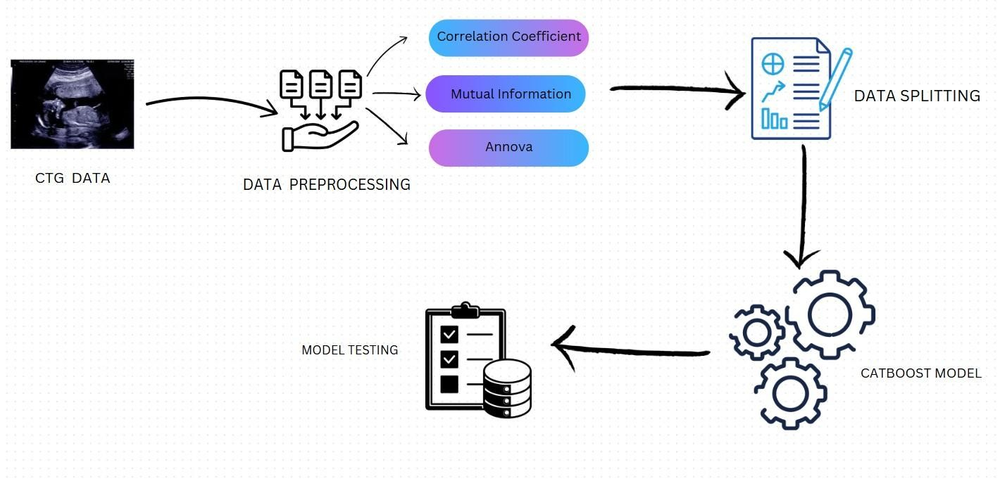
Fig. 1 Structural framework of CatBoost based classification framework

Because they are more likely to be predictive, features with high absolute CC are chosen. Each feature was assigned a rank based on its importance score in the respective methods. Specifically, features with higher CC, MI, or ANOVA scores received better ranks. The optimal feature set size of each FS technique is decided by simulating over different feature set sizes. depth of each tree are defined. CatBoost is a machine learning algorithm based on the gradient boosting framework with two primary characteristics. Like gradient boosting, it combines the predictions from several weak learners, usually DTs to make inferences, but it is also optimized for handling categorical data efficiently. As it can handle the datasets with a mix of numerical and categorical features, and works well on small and imbalanced datasets so making it a suitable choice for fetal state identification on CTG data. After training the CatBoost classifier on train set, lastly, the model is assessed using the four classification criteria as presented in Eq. (1) to (4). These are derived from the confusion matrix, which is produced by emphasizing on key variables and reducing dimensionality, this stage account for diverse perspectives on feature relevance for enhancing model performance.
Then the training and test set are formed with the specified split ratio and the key hyperparameters of the CatBoost classifier Key hyperparameters of the CatBoost model, including tree depth and learning rate, were carefully selected to optimize performance.

Accuracy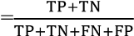
TP
Precision=
TP
Recall=
F1-score=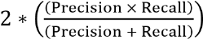

III. EXPERIMENTAL RESULT
DISCUSSION

This section presents the performance evaluation of the proposed CatBoost model and compares it with other machine learning techniques.
Based on the results presented in Table 1, the CatBoost model demonstrates superior performance compared to other classifiers, even without applying any feature selection techniques.
Model | Accuracy | Precision | Recall | F1 Score
RF | 0.948357 | 0.947156 | 0.948357 | 0.947391
KNN | 0.915493 | 0.912144 | 0.915493 | 0.912794
DT | 0.922535 | 0.926306 | 0.922535 | 0.923800
SVM | 0.903756 | 0.904599 | 0.903756 | 0.903630
XGBoost | 0.960094 | 0.959859 | 0.960094 | 0.959967
CatBoost | 0.962441 | 0.962004 | 0.962441 | 0.962050
Table 1 Performance comparison of CatBoost with other classifiers without FS

five ML classifiers with the CatBoost classifier for fetal state identification by analysing the CTG data. By evaluating the CatBoost classifier’s performance using three FS approaches, the effect of FS on its performance is evaluated. Additionally, by examining the classifier’s performance with a range of feature sizes, the ideal feature set and FS approach are pinpointed.

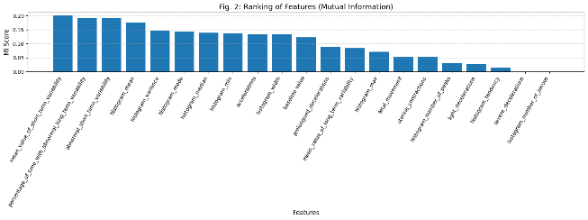
Fig.2 Ranking of Features (MI)
compared to other classifiers, The results show that the CatBoost model achieves better performance with high accuracy, precision, recall, and F1-score.
In the next phase, the CatBoost classifier’s performance is evaluated using three FS approaches to investigate if reducing the feature set could further enhance model performance or improve computational efficiency. Fig. 2, 3, 4 represents the ranking of the features obtained by MI, ANOVA, and CC based
FS approaches respectively.

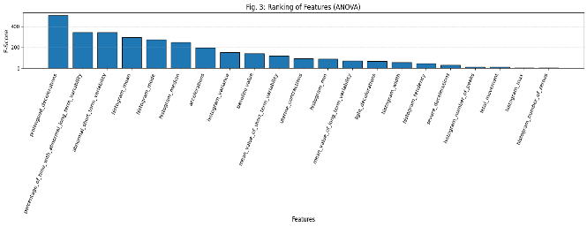

Fig.3 Ranking of Features (ANOVA)

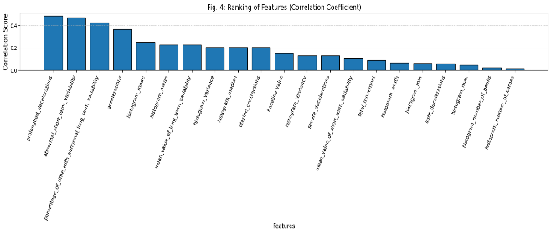
Fig.4 Ranking of features (CC)
To determine the ideal feature set size of each FS technique, the performance of the CatBoost classifier is evaluated with 20 feature set sizes ranging from 2 to 21 for each FS technique as depicted in Table 2.
The highest accuracy obtained by each FS technique and the corresponding feature set size is highlighted in the Table 2. According to Table 2, CatBoost with ANOVA yields the
Feature  set size | MI | ANOVA | CC
2 | 0.88 | 0.84 | 0.82
3 | 0.89 | 0.91 | 0.91
4 | 0.94 | 0.93 | 0.91
5 | 0.94 | 0.94 | 0.94
6 | 0.96 | 0.95 | 0.95
7 | 0.96 | 0.94 | 0.94
8 | 0.95 | 0.96 | 0.95
9 | 0.96 | 0.96 | 0.96
10 | 0.95 | 0.96 | 0.96
11 | 0.95 | 0.96 | 0.96
12 | 0.96 | 0.96 | 0.96
13 | 0.96 | 0.96 | 0.96
14 | 0.96 | 0.97 | 0.96
15 | 0.97 | 0.97 | 0.96
16 | 0.96 | 0.96 | 0.97
17 | 0.96 | 0.96 | 0.96
18 | 0.96 | 0.96 | 0.97
19 | 0.96 | 0.96 | 0.97
20 | 0.96 | 0.96 | 0.96
21 | 0.97 | 0.97 | 0.96
Table 2 Accuracy of CatBoost classifier with different feature set sizes with respect to three
FS techniques

feature set size of 15.
In contrast, the same accuracy is seen with more reduced feature set size of 14 when using ANOVA, and with feature set size of 16 when using CC. Overall analysis reveals that, out of all FS approaches, CatBoost with ANOVA produces the best accuracy with a minimum of 14 features, which are depicted as the top 14 ranked features in Fig. 3.

The CatBoost model gets good results when it uses a small group of features. It can get it 97 percent of the time with just 15 features.. We found out that we can get almost the same results with even fewer features if we use different ways to pick them. For example if we use ANOVA it can get the results with just 14 features. The CC method needs 16 features to get results. This shows that ANOVA is really good at finding the important features without using too many. So when we use CatBoost with ANOVA to pick features it works well. It is the way to get good results without using too many features. The 14 important features are shown in Fig. 3. We can see that using a group of good features is enough to get really good results and it is not too complicated. CatBoost and ANOVA are a team. CatBoost and ANOVA help us get results, with fewer features.
The Confusion matrix obtained by the CatBoost classifier using ANOVA for the test set as shown in Fig. 5 further reveals minimal discrepancies such as 13 false positive cases out of 426. Finally, the class wise precision, recall and F1-score of test data obtained by CatBoost using ANOVA based FS and without using any feature selection is depicted in Table 3 and the corresponding visual analysis is depicted in Fig. 6. As can be seen from Table3 and Fig. 6, the precision, recall and F1-score in most cases has generally improved or stay the same with reduced feature set, with the exception of class 3’s precision and F1-score, which may be impacted by the smaller number of samples in that class. Overall, results indicate that selecting fewer features while maintaining high feature relevance leads to improved model performance. Selecting the top 14 features strikes a balance between performance and dimensionality reduction, ensuring that the model performs optimally while remaining computationally efficient.

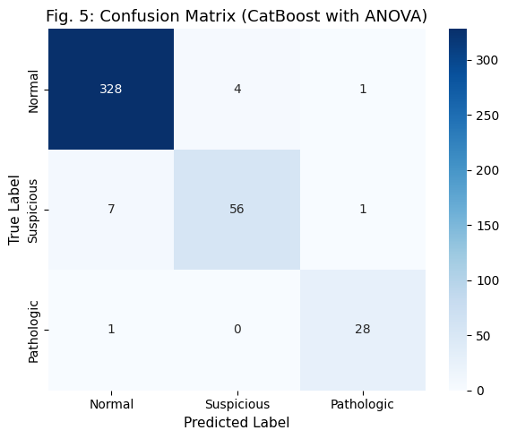
IV CONCLUSION
In this study, the performance of the CatBoost classifier combined with three feature selection (FS) techniques—ANOVA, Mutual Information (MI), and Correlation Coefficient (CC)—was analyzed for fetal health classification using cardiotocography (CTG) data. The main objective was to improve prediction accuracy while reducing misclassification, especially between normal, suspicious, and pathological cases.

Fig.4 Ranking of features (CC)

Class value | Precision ( with all features) | Precision (with 14 features) | Recall  ( with all features) | Recall (with 14 features) | F1 score (with all features) | F1 score (with 14 features)
Normal (1) | 0.98 | 0.98 | 0.98 | 0.98 | 0.98 | 0.98
Suspicious (2) | 0.93 | 0.93 | 0.88 | 0.88 | 0.90 | 0.90
Pathologic (3) | 0.93 | 0.93 | 0.97 | 0.97 | 0.95 | 0.95
Table 3 Performance comparison of CatBoost classifier without FS and with ANOVA based FS

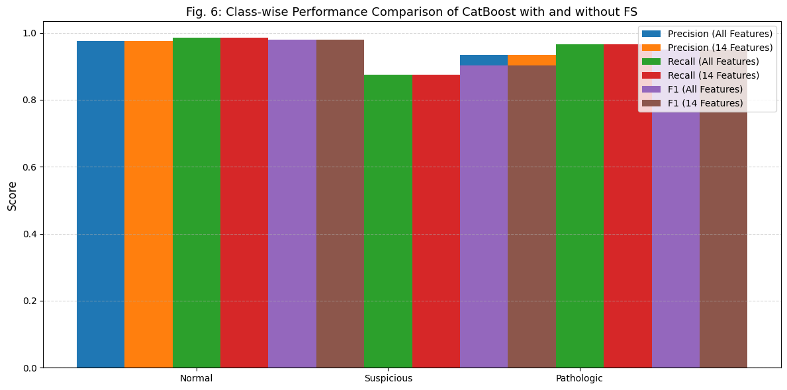
Fig. 6 Class wise performance comparison of CatBoost with and without FS

The results show that the CatBoost model performs better than other machine learning classifiers such as Random Forest, K-Nearest Neighbour, Decision Tree, Support Vector Machine, and XGBoost across key evaluation metrics including accuracy, precision, recall, and F1-score. This reflects the effectiveness and stability of the CatBoost approach in handling structured medical data.
In addition, the use of feature selection techniques improved the model’s efficiency by reducing dimensionality and focusing on the most relevant features. Among the methods used, ANOVA provided the best performance, achieving an accuracy of 97% while reducing the feature set from 21 to 14. This not only enhances computational efficiency but also helps in maintaining strong predictive performance with fewer inputs.
Overall, the study shows that combining CatBoost with suitable feature selection techniques provides a reliable and efficient approach for fetal health prediction. This approach may assist healthcare professionals in early detection of fetal distress, helping in timely intervention and better clinical decision-making.
Future work will focus on further automation and integration of advanced models to enhance interpretability, scalability, and real-time applicability in maternal-fetal healthcare systems.

REFERENCES
- H. Sahin and A. Subasi, “Classification of the cardiotocogram data for anticipation of fetal risks using machine learning techniques,” Applied Soft Computing, vol. 33, pp. 231–238, 2015.
- M. S. Iraji, “Prediction of fetal state from the cardiotocogram recordings using neural network models,” Artificial Intelligence in Medicine, vol. 96, pp. 33–44, 2019..
- S. P. Potharaju, M. Sreedevi, V. K. Ande, and R. K. Tirandasu, “Data mining approach for accelerating the classification accuracy of cardiotocography,” Clinical Epidemiology and Global Health, vol. 7, no. 2, pp. 160–164, 2019.
- J. Piri, P. Mohapatra, and R. Dey, “Fetal health status classification using MOGA-CD based feature selection approach,” in Proc. 2020 IEEE International Conference on Electronics, Computing and Communication Technologies (CONECCT), 2020, pp. 1–6.
- A. Subasi, B. Kadasa, and E. Kremic, “Classification of the cardiotocogram data for anticipation of fetal risks using bagging ensemble classifier,” Procedia Computer Science, vol. 168, pp. 34–39, 2020.
- Y. Chen, A. Guo, Q. Chen, B. Quan, G. Liu, L. Li, J. Hong, H. Wei, and Z. Hao, “Intelligent classification of antepartum cardiotocography model based on deep forest,” Biomedical Signal Processing and Control, vol. 67, p. 102555, 2021.
- R. Zeng, Y. Lu, S. Long, C. Wang, and J. Bai, “Cardiotocography signal abnormality classification using time-frequency features and ensemble cost-sensitive SVM classifier,” Computers in Biology and Medicine, vol. 130, p. 104218, 2021.
- K. N. R. Sree, G. Jotheeswaran, and D. Chitradevi, “Predicting fetal health: A machine learning approach using Random Forest algorithm,” in Proc. 2023 International Conference on Artificial Intelligence Innovation in Healthcare Industries (ICAIIHI), vol. 1, pp. 1–6, 2023.
- A. Kuzu and Y. Santur, “Early diagnosis and classification of fetal health status from a fetal cardiotocography dataset using ensemble learning,” Diagnostics, vol. 13, no. 15, p. 2471, 2023.
- Y. Salini, S. N. Mohanty, J. V. N. Ramesh, M. Yang, and M. M. V. Chalapathi, “Cardiotocography Data Analysis for Fetal Health Classification Using Machine Learning Models,” IEEE Access, 2024.
- M. O’Sullivan, T. Gabruseva, G. Boylan, M. O’Riordan, G. Lightbody, and W. Marnane, “Classification of Fetal Compromise During Labour: Signal Processing and Feature Engineering of the Cardiotocograph,” arXiv preprint arXiv:2111.00517, 2021.
- M. J. Khan, M. Vatish, and G. D. Jones, “PatchCTG: Patch Cardiotocography Transformer for Antepartum Fetal Health Monitoring,” arXiv preprint arXiv:2411.07796, 2024.
- F. Francis et al., “Machine Learning on Cardiotocography Data to Classify Fetal Compromise: A Systematic Review,” Computers in Biology and Medicine, vol. 176, 2024, Art. no. 108507.
- N. Rahmayanti et al., “Comparison of Machine Learning Algorithms to Classify Fetal Health,” Procedia Computer Science, vol. 197, pp. 162–169, 2022.
- J. Piri and P. Mohapatra, “Exploring fetal health status using an association based classification approach,” in Proc. 2019 International Conference on Information Technology (ICIT), 2019, pp. 166–171.
- S. Das, H. Mukherjee, K. Roy, and C. K. Saha, “Fetal Health Classification from Cardiotocograph for Both Stages of Labor—A Soft-Computing-Based Approach,” Diagnostics, vol. 13, no. 5, p. 858, 2023.
- A. Mehbodniya, A. J. P. Lazar, J. Webber, D. K. Sharma, S. Jayagopalan, K. Kousalya, P. Singh, R. Rajan, S. Pandya, and S. Sengan, “Fetal Health Classification from Cardiotocographic Data Using Machine Learning,” Expert Systems, vol. 39, no. 6, Art. no. e12899, 2022.
- A. Mehbodniya, A. J. P. Lazar, J. Webber, D. K. Sharma, S. Jayagopalan, K. Kousalya, P. Singh, R. Rajan, S. Pandya, and S. Sengan, “Fetal Health Classification from Cardiotocographic Data Using Machine Learning,” Expert Systems, vol. 39, no. 6, Art. no. e12899, 2022.
- A. Kuzu and Y. Santur, “Early Diagnosis and Classification of Fetal Health Status from a Fetal Cardiotocography Dataset Using Ensemble Learning,” Diagnostics, vol. 13, no. 15, p. 2471, 2023.
- A. Kuzu and Y. Santur, “Early Diagnosis and Classification of Fetal Health Status from a Fetal Cardiotocography Dataset Using Ensemble Learning,” Diagnostics, vol. 13, no. 15, p. 2471, 2023.
- R. K. Bhukya et al., “Enhancing Fetal Health Classification: A Study on Fetal Cardiotocography Data Using Machine Learning and Deep Learning,” Procedia Computer Science, 2025.
- IndiaAI, “Fetal Health Classification Using Machine Learning on Cardiotocography Data,” IndiaAI Case Study, 2025.
- M. O’Sullivan, T. Gabruseva, G. Boylan, M. O’Riordan, G. Lightbody, and W. Marnane, “Classification of Fetal Compromise During Labour: Signal Processing and Feature Engineering of the Cardiotocograph,” arXiv preprint arXiv:2111.00517, 2021.
- B. Regmi and C. Shah, “Classification Methods Based on Machine Learning for the Analysis of Fetal Health Data,” arXiv preprint arXiv:2311.10962, 2023.
- M. J. Khan, M. Vatish, and G. D. Jones, “PatchCTG: Patch Cardiotocography Transformer for Antepartum Fetal Health Monitoring,” arXiv preprint arXiv:2411.07796, 2024.
- G. Mushtaq et al., “AI Driven Interpretable Deep Learning Based Fetal Health Classification,” Diagnostics, vol. 11, no. 10, p. 1835, 2021.
- M. O’Sullivan, T. Gabruseva, G. Boylan, M. O’Riordan, G. Lightbody, and W. Marnane, “Classification of Fetal Compromise During Labour: Signal Processing and Feature Engineering of the Cardiotocograph,” arXiv preprint arXiv:2111.00517, 2021.
- F. Francis, S. Luz, H. Wu, S. J. Stock, and R. Townsend, “Machine Learning on Cardiotocography Data to Classify Fetal Outcomes: A Scoping Review,” Computers in Biology and Medicine, vol. 176, Art. no. 108507, 2024.
- I. Nazli et al., “Early Detection of Fetal Health Conditions Using Machine Learning,” Diagnostics, vol. 15, no. 10, p. 1250, 2025.
- T. Kaya et al., “Deep Learning and Optimization-Based Feature Selection for Fetal Health Assessment Using Cardiotocography Signals,” Biomedical Engineering Advances, 2025.
- G. Mushtaq et al., “AI Driven Interpretable Deep Learning Based Fetal Health Classification,” Healthcare Analytics, vol. 5, 2024.
- B. Regmi and C. Shah, “Classification Methods Based on Machine Learning for the Analysis of Fetal Health Data,” arXiv preprint arXiv:2311.10962, 2023.
- M. J. Khan, M. Vatish, and G. D. Jones, “PatchCTG: Patch Cardiotocography Transformer for Antepartum Fetal Health Monitoring,” arXiv preprint arXiv:2411.07796, 2024.
- S. S. Ahmed et al., “Early Detection of Fetal Health Status Based on Artificial Intelligence Techniques,” Neural Computing and Applications, 2025.
- W. K. Wong et al., “Kolmogorov–Arnold Networks for Automated Fetal Health Classification from CTG Recordings,” PMC/Medical AI Study, 2025.
- R. Pardasani et al., “Development of a Novel Artificial Intelligence Algorithm for Automated Cardiotocography Interpretation,” Frontiers in Digital Health, 2025.
- A. Petrozziello, C. W. Redman, A. T. Papageorghiou, I. Jordanov, and A. Georgieva, “Multimodal Convolutional Neural Networks to Detect Fetal Compromise During Labor and Delivery,” IEEE Access, vol. 7, pp. 112026–112036, 2019.
- X. Zhou et al., “Objective Interpretation of Intrapartum Cardiotocography Using Deep Learning,” Scientific Reports, 2026.

